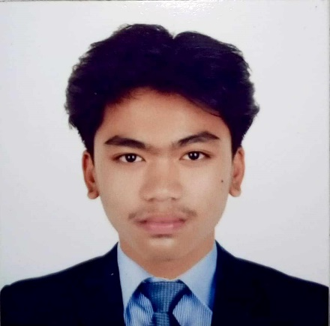

**KELVIN LEE P. CLEMENTE**

**Address: PUROK 3, PULONGYANTOK, ANGAT, BULACAN**

**Hand Phone No. 09514200340**

**Email Address: clementekelvinlee@gmail.com**

***OBJECTIVE:***

To be part of company that will provide an opportunity to develop more my skills and experience and gain more knowledge and be able to contribute to the advancement of the company.

***PERSONAL DATA***

**Age:** 19

**Gender:** Male

**Birthday:** August 10, 2004

**Height:** 5’9

**Weight:** 63 kg

**Birthplace:** Norzagaray, Bulacan

**Civil Status:** Single

**Citizenship:** Filipino

**Religion:** Born Again Christian

**Mother’s Name:** Reycie Jane P. Clemente

**Occupation:** House Wife

**Father’s Name:** Roland SP. Clemente

**Occupation:** Driver

***SKILLS***

* Ability to communicate well to others
* Computer literate
* Willing to stretch existing working hours to

accommodate work

* Flexible in any work

***EDUCATIONAL BACKGROUND***

*Senior High Education*

* Angel M. Del Rosario High School

SHS Graduate 2021-2022

*Secondary Education*

* Angel M. Del Rosario High School

HS Graduate 2019-2020

*Primary Education*

* Kaypian Elementary School

Elementary Graduate 2014-2015

***WORK EXPERIENCE***

2023 - Lazada sorter (STM Hub)

2022 - Lazada sorter (MSC Hub)

2022 - Work Immersion

2020 - Mineral Water Refilling Station

***CHARACTER REFERENCES***

**Ms. Mel Rose R. Bacsal**

09957138695

Licensed Professional Teacher

**Ms. Maricel SP. Clemente**

09491949454

Certified Public Accountant

**Ms. Louella C. Goli Cruz**

09308662542

Site Electrical Engineer

*I hereby certify that the above information is true and correct to the best of my knowledge and belief.*

**KELVIN LEE P. CLEMENTE**

Applicant